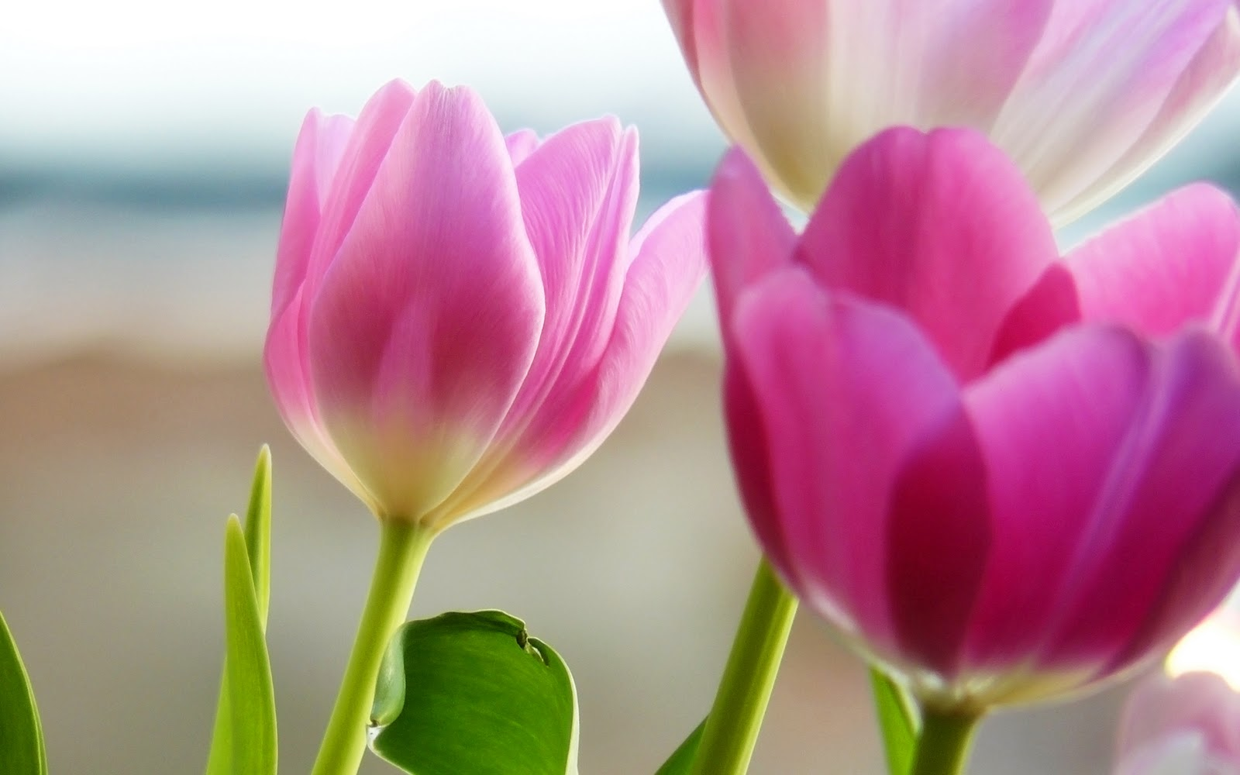
Maple Class April Update
Dear Parents and Students,
I hope you have enjoyed a restful spring break. It is great to see everyone again and I am excited for us to dive into the third term. Here are some of the highlights of upcoming themes and events:
In science and socials, we will continue to learn about stewardship concepts related to animal species and the environment. There are several field trips planned including the salmon fry release to Goldstream Park, a recycle tour of the Hartland Learning Center as well as a visit to a local park with a Songhees Nation environmentalist. We will make connections through art beginning with a look at the nature installations of Andy Goldsworthy including an opportunity to explore his technique as well a visit to the Robert Bateman Center to learn about this environmentally conscious artist and his work. And finally we will receive a lesson from our own resident bird expert, Hayden from the Cedar class, to highlight what he knows about songbirds. In celebration of Earth Day, we will create several useful crafts and one engineering project all from recycled items from home. Stay tuned for more details!
This term there will be a big emphasis on reading comprehension and using conventional English in our writing. We will begin a sticker incentive routine for home reading as well as regular Friday spelling tests and our morning routine will include a greater variety of brain challenges to start the day. In Math we will begin working on multiplication concepts and will be introduced to daily ‘mad minutes’ drills to increase math fluency.
Happy Spring! Heather
Important Dates
- CRD Hartland Learning Center Field Trip Tues. April 12
- Hot lunch /Grub day Fri. April 15
- Salmon Fry Release Field Trip to Goldstream Friday April 22
- Swimming Lessons Thurs. April 21, 28 May 5,12,19,26 June 2, 9

2 Requests from home:
- plastic grocery bags ( if you have any) &
- empty milk cartons

